**Lab sheet 2**

**CSS**

**Part 1:**

1. Give an example of inline CSS of your choice. (use at least 5 html elements)
2. Give an example of internal CSS. (use at least 5 html elements)
3. Give an example of external CSS. (use at least 5 html elements)
4. Give an example of simple selector and grouping selector. (use at least 5 html elements).
5. Design a webpage using <p> tag and <h1> tag and make font color red, background color yellow and font family “time new roman” for all element using universal selector.
6. Design a webpage using attribute selector. Give proper example using:
   1. CSS [attribute] Selector
   2. CSS [attribute="value"] Selector
   3. CSS [attribute~="value"] Selector
   4. CSS [attribute|="value"] Selector
   5. CSS [attribute^="value"] Selector
   6. CSS [attribute$="value"] Selector3
   7. CSS [attribute*="value"] Selector
7. Design a webpage using pseudo class selector.
8. Design a webpage using pseudo element selector.
9. Design a webpage using combinator selector. Give proper example using:
   1. Descendant selector
   2. Child selector
   3. Adjacent sibling selector
   4. General sibling selector
10. Design a webpage using background image with additional CSS properties like background-repeat, background-position, background-size.
11. Design a webpage using border-style, border-color and border-width like below:

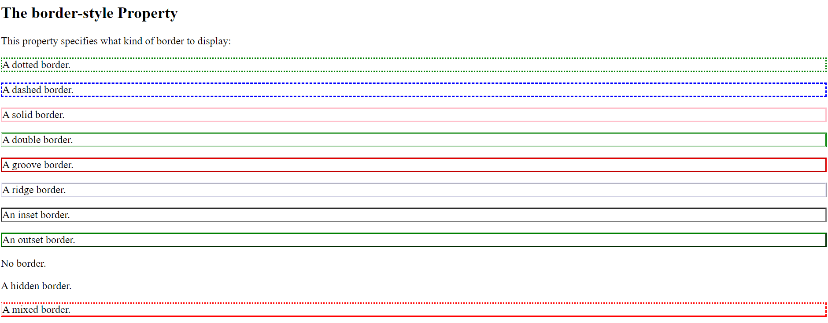

1. Design a webpage using individual border style like below:

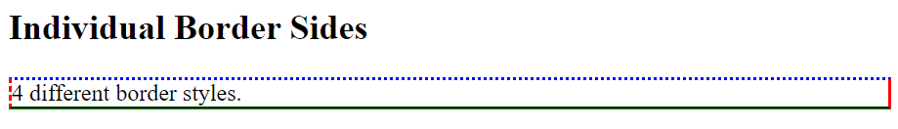

1. Design a webpage using border-radius property like below:

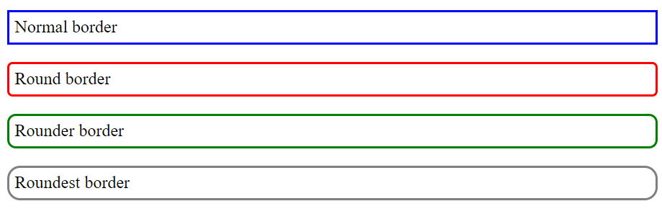

1. Design a webpage using CSS margin property and also explore single value, two values, three values, four values, auto and inherit.

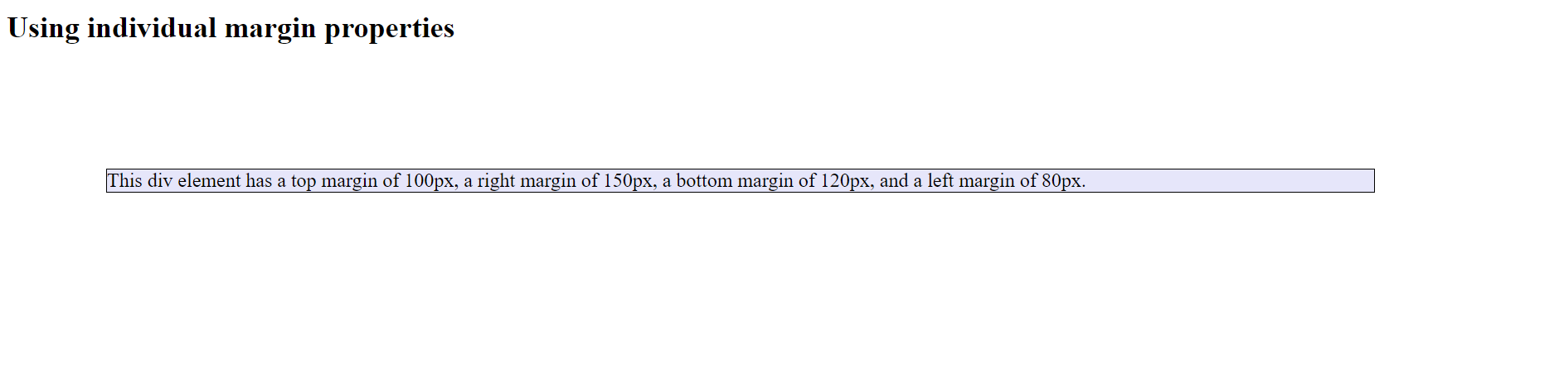

1. Design a webpage using CSS individual padding property:

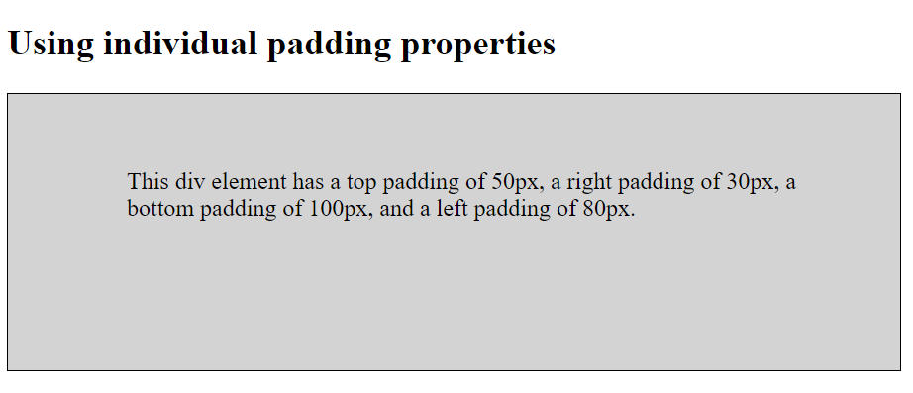

**Part 2**

1. Give an example using text styling. (Use color, letter-spacing, word-spacing, text-align, text decoration, text-transform and text-shadow property).
2. Design a webpage like below using css property:

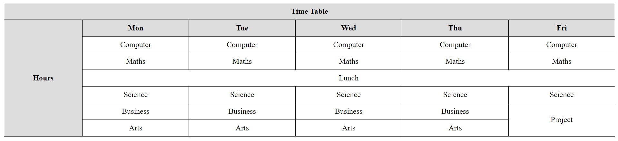

1. Design a webpage like below using css property:

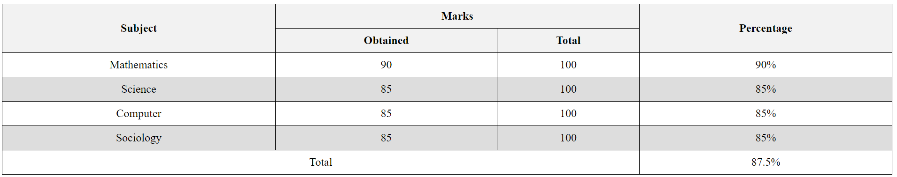

1. Give an example using list-style-type, list-style-position and list-style-image.
2. Design a webpage using <form> tag and CSS property.

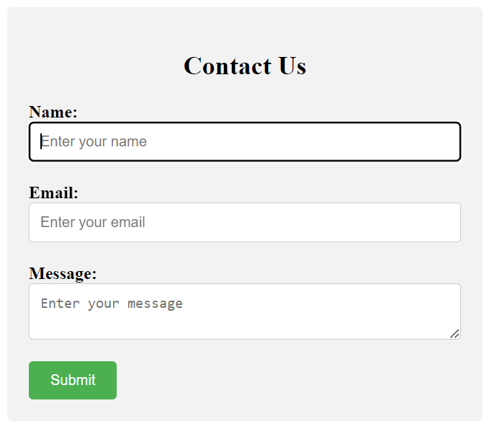

1. Display a horizontal list of link using CSS display property.

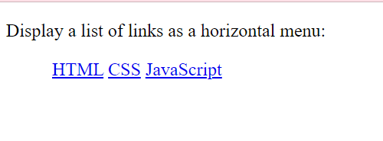

1. Design a webpage using CSS Max-width property and find the difference between width and max-width.
2. Design a webpage using CSS Overflow property. Make sure to explore values of overflow property which are hidden, visible, scroll and auto.
3. Make small boxes using HTML elements and CSS. And use CSS float property with the value left or right.

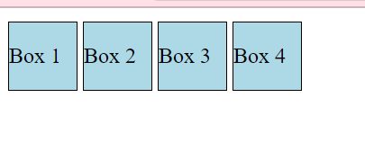

1. Add icon to your HTML page with an icon library such as Font Awesome.

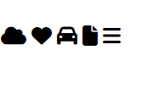

1. Give an example using CSS Box-sizing property and see the difference between content box(default) and border box.
2. Give an example using CSS Position property with static, fixed, sticky, relative and absolute value.
3. Make 3 boxes and add position with z-index property and overlap the element.
4. Give an example using media queries.